SWIPEIO-Requirements Document

SwipeIO

SwipeIO is a web application which tells about the Number of Employees, Average Working Hours and Defaulters which is based on their IN/OUT Timings.

SCREENS:

* Login
* Dashboard
* Report
* Add/Remove
* Settings
* Import

LOGIN**:-**

* Invoke the SwipeIO login page. After invoking login page asks to enter the Email and Password of the Employee.
* The Login can be done by Employees which is categorized as Admins and Contracts.
* The contents of verifying the login page is provided by the database by matching details of Email and Password is correct and authentication is provided by the middleware(i.e. Backend) which tells the employee exists or it should throw error codes based on their invalid data.

**API:** <http://localhost:4200/>employees/validateLogin

Request payload:

{

email:

password:

}

Response:  
{

status:

data:

}

**Front end:**

* Use the above api to validate the email id and password provided by the user
* If the user is validated successfully then status will be ‘ok’ with data as employee Id otherwise status as ‘bad’ with error code in the data.

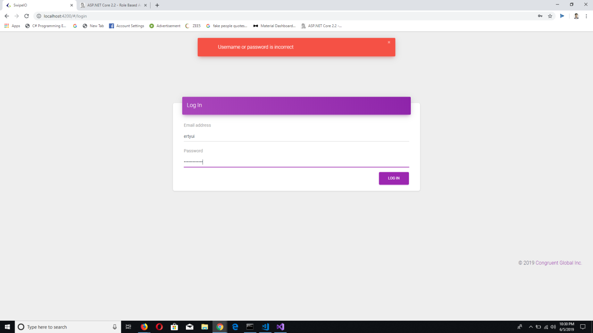

**Back end:**

* Implement the API
* Validate the login by passing details to the stored procedure
* Gets the date from the stored procedure and check against the email and password match
* Based on the response of the SP, check if both the email and password match with response of SP ,send the status as ‘ok’ and data as employeeId.
* Validate for the email and password and send the respective error code , refer Error code and error messages and send status as ‘bad’

**Database end:**

* Create a stored procedure with the following details

**SP Name** : getEmployeeLoginDetails

**Params**:

email – string

Password – string

**Output**:

Match of both email and password as array of value which will have employeeId.

# Error code **and** error messages

|  |  |  |  |
| --- | --- | --- | --- |
| **Category** | **Sub category** | **Error Code** | **Error Message** |
| Login |  | L01 | Email and password mandatory |
|  |  | L02 | Email id not found |
|  |  | L03 | Password doesn’t match with email |
|  |  |  |  |